Unit 1

Introduction

Computers have become a powerful tool for the rapid and economical production of pictures.   
There is virtually no area in which graphical displays cannot be used to some advantage, and so   
it is not surprising to find the use of computer graphics so widespread. Computer graphics is the   
creation, display, manipulation and storage of picture and experimental data for proper   
visualization using a computer. It is the pictorial synthesis of real and/or imaginary objects from   
their computer-based models (or data sets). William Fetter coined term “computer graphics” in   
1960 to describe new design methods he was pursuing at Boeing. He created a series of widely   
reproduced images on pen plotter exploring cockpit design, using 3D model of human body.

These images of objects are generated from various fields such as science, engineering, medicine, business, industry, government, art, entertainment, advertising, education, and training. Computer graphics today is largely interactive, that is, the user controls the contents, structure, and appearance of images of the objects by using input devices, such as keyboard, mouse, or touch-sensitive panel on the screen.

History of Computer Graphics

The history of the computer graphics can be study as a chronicle development of hardware and software. The evolution of graphics under various terms is described on following points.

- Crude plotting on hardcopy devices such as teletypes and line printers dates from the early days of computing.

- The whirlwind computer developed in 1950 at Massachusetts institute of Technology ( MIT)   
had computer-drive CRT displays for output, both for operator use and for cameras producing   
hard copy.

- The SAGE air-defense system developed in the middle 1950’s was the first to use command and control CRT displays console on which operators identified targets with the light pens

The beginning of modern interactive graphics, however were found in IVAN SUTHER LAND’S   
seminal doctoral work on the sketchpad drawing systems. He introduced data structures for   
storing symbol hierarchies built up via replication of standard components ( used for drawing   
circuit symbols). He also developed interaction technique that use the keyboard and light pen for   
making choices, pointing and drawing and formulating many other ideas and technique that are   
still in use today.

- By the mid- sixties, a number of research projects and commercial products had appeared as the   
potentially of CAD activities in computer, automobile and aerospace grew enormously for   
automating drafting-insensitive activities. The general motor system for automobile design and

Intek Digitek system for lens design were pioneers in showing the efforts utilizing graphics interaction in the interactive cycle’s common in engineering.

- Due to the high cost of graphics hardware, expensive computing resources, difficulty in wring   
large interactive program and due to many other reasons the human computer interaction was   
still done primarily in both mode using punched cards. After the advent of graphics based   
personal computers such as Apple Macintosh and IBM PC , the costs of both hardware and   
software was driven down. Millions of graphics computer were sold exclusively for offices and   
home. Thus the interactive graphics (GUI) as “the window on the computer” became an integral   
part of PC featuring graphical interaction. The reason for making interactive graphics affordable   
was because of the advent of direct-view storage tube (DVST) which replace buffer and refresh   
process and eliminated all flicker in the system. Before this, buffer memory and processors were   
enough only to refresh at 30HZ and only few thousand lines could be drawn without noticeable   
flicker.

- Another major hardware advance of late sixties was attaching a display is a minicomputer, relieving heavy demands of refreshed display devices (like user interaction handling and updating image on the screen) with the central-time sharing computer.

- In 1968, another such devices was invented. The refresh display hardware for geometric transformations could scale, rotate and translate points and lines on the screen at real time; perform the 2D and 3D clipping and could produce parallel and perspective projections.

- The development of inexpensive raster graphics, based on television technology in early   
seventies contributed more to the growth of the field. The Raster displays stores displays stores   
display primitives (lines, characters or areas) in a refresh buffer. The development of graphics   
cannot be stand-off without the study of graphics input technology. The clumsy, fragile light pen   
has been replaced by mouse, the tablet, touch panel, digitizers and other devices. Interaction to   
computer using devices require no knowledge of programming and only a little keyboard use; the   
use makes choices by selecting menus, icons , check options, places predefined symbols on   
screen and draws by indicating consecutive end points to be connected by lines or interpolated   
by smooth curves and fills closed areas bounded by polygons or point contours with shades of   
gray, colors on various patterns. Now computer graphics have become integral and essential   
technology in the computers system.

**Advantages of Computer Graphics**

In every field, we need large number of information to be analyzed and study the behaviors of   
certain processes. Numerical simulations in supercomputers, satellite cameras and other sources   
are amassing large amount of data files faster they can be interpreted. Scanning these huge   
amounts of data files to determine their nature and relationships is a tedious job. But if the data   
are converted to a visual form it is very easier to infer various conclusions immediately.   
Producing graphical presentations for scientific, engineering and medical data sets and processes

is generally referred to as scientific visualization. If the data sets are concerned with commerce,   
industry and other non-scientific areas, it is called business visualization. Computer graphics has   
great advantage in visualizing such data. Today, almost all interactive application programs,   
even those for manipulating text (e.g. word processor) or numerical data (e.g. spreadsheet   
programs), use graphics extensively in the user interface and for visualizing and manipulating the   
application-specific objects.

Even people who do not use computers encounter computer graphics in TV commercials and as   
cinematic special effects. Thus computer graphics is an integral part of all computer user   
interfaces, and is indispensable for visualizing 2D, 3D objects in all most all areas such as   
education, science, engineering, medicine, commerce, the military, advertising, and   
entertainment. The theme is that learning how to program and use computers now includes   
learning how to use simple 2D graphics. There is virtually no area in which graphical displays   
cannot be used to some advantages.

Area of Applications

Computer graphics started with the display of data or hard copy plotter and CRT screens had grown include the creation, storage and manipulation of mode is of images of objects.We find computer graphics used in a diverse areas as science, engineering , medicine business, industry, government, art, entertainment ,education and others.

COMPUTER AIDED DESING (CAD):

A major use of computer graphics is in design processes, particularly for engineering and   
architectural systems, but almost all products are now computer designed. Generally referred to   
as CAD, computer-aided design methods are now routinely used in the design of buildings,   
automobiles, aircraft, watercraft, spacecraft, computers, textiles, and many, many other products.   
In CAD, interactive graphics is used to design components and systems of mechanical, electrical,   
electromechanical and electronic devices including structures such as buildings, automobile   
bodies, airplane, VLSI chips, optical systems and telephone and computer networks. The   
emphasis is on interacting with a computer-based model of the component or system being   
designed in orders to test, for example its structural, electrical or thermal properties. The model   
is interpreted by a simulator that feeds back the behavior of system to the user for further   
interactive design and test cycles. Some mechanical parts are manufactured by describing how   
the surfaces are to be formed with machine tools. Numerically controlled machine tools are then   
set up to manufacture the parts according to these construction layouts.

Architects use interactive graphics method to layout floor plans that shows positioning of rooms, doors, windows, stairs, shelves and other building features. An electrical designer then tries out arrangements for wiring, electrical outlets and other system to determine space utilization on a building. The realistic displays then allows architects and their clients to study appearance of building and even go for a simulated “walk” through rooms or around building.

PRESENTATION GRAPHICS:

Another major application areas of computer graphics is the “Presentation Graphics”.   
Presentation Graphics are used to provide illustrations for reports or to generate transparencies   
for use with graphics. Presentation Graphics is commonly used to summarize financial,   
statistical, mathematical, scientific and economic data for research reports, managerial reports   
and other types of reports. Typical examples are bar charts, line graphs, surface graphs, pie   
charts and other displays showing relationship between multiple variables. The 3D graphics are   
usually used simply for effects; they can provide a more diagrammatic or more attractive   
presentation of data relationship. Various representative of presentation graphics are:

Computer Art:

Computer graphics is used to generate arts. They are widely used in both fine art and commercial   
art applications. Fine arts are drawn by artist hand and this kind of art is perfect to the artist skill.   
Artist use a variety of computer methods including special purpose hardware, artists paint brush   
program, other paint packages. Moreover, artists use a touchpad or a stylus or digitizer to draw   
pictures. The movement of object is captured by some input hardware. These arts are usually   
generated by using mathematical functions or algorithms. Computer art is not as realistic as fine   
arts. Commercial art uses animations to demonstrate or present commercial products to the   
public. Fine artists use a variety of computer techniques to produce images. These images are   
created using a combination of 3D modeling package, texture mapping, drawing programs and   
CAD software.

These technique for generating electronic images are also applied in commercial art for logos   
and other design, page layouts combining text and graphics, TV advertising, sports, and other   
areas. Animations are also used frequently in advertising and TV commercial and produce frame   
by frame, where each frame of the motion is rendered and saved as an image file. A common   
graphics method employed in many commercials is morphing, where one object is transformed   
into another.

Education and training:

Computer graphics is used in education and training for making it more effective and more   
illustrative. E.g. if a teacher is to teach bonding of molecules or electron jump from higher   
energy state to lower energy state or the structure of gene, then he can demonstrate these   
concepts using computer graphics software or presentations. Another example could be taken for   
surgery. A student can learn surgery using data gloves and realistic computer graphics. The cost   
of education as well as risk of human life is reduced. Other examples could be flight simulator   
and driving simulator for pilot and driving training. Models of physical systems, physiological   
systems, population trends or equipments such as the color coded diagram also help trainees to   
understand the operation of the system.

**Entertainment:**

Computer graphics methods are now commonly used in making motion pictures, music videos and TV shows. Images are drawn in wire-frame form and will be shaded with rendering methods to produce solid surfaces. Music videos use graphics in several ways. Graphics objects can be combined with the line action. Computer graphics are also used to introduce virtual characters to movies like character in “Ice Age”,"Avatar”.

**Visualization:**

Scientists, engineers, medical personnel, business analysts, and others often need to analyze large   
amounts of information or to study the behavior of certain processes. Numerical simulations   
carried out on supercomputers frequently produce data files containing thousands and even   
millions of data values. Similarly, satellite cameras and other sources are amassing large data   
files faster than they can be interpreted. Scanning these large sets of number to determine trends   
and relationships is a tedious and ineffective process. But if the data are converted to a visual   
form, the trends and patterns are often immediately apparent. Some methods generate very large   
amount of data/information for example a survey of one million people’s choice for using   
different toothpaste generates large amount of data. Analyzing the property of the whole amount   
of data is difficult. Therefore to visualize large amount of information, graphical computer   
systems are used.

**Image Processing:**

Image processing applies techniques to modify or interpret existing pictures, such as photographs and TV scans. Two principal applications of image processing are (1) improving picture quality and (2) machine perception of visual information, as used in robotics. Image can be created using simple point program or can be fed into computer by scanning the image. These picture/ images need to be changed to improve the quality. For image/pattern recognition systems, images need to be changed in specified format so that the system can recognize the meaning of the picture. For example scanners with OCR features must have letters similar to standard font set. Medical applications also make extensive use of image processing techniques for picture enhancements, in tomography and in simulations of operations.

**Graphical user Interface:**

It is common now for software packages to provide a graphical interface. GUIs have become key   
factors for the success of the software or operating system. A major component of a graphical   
interface is a window manager that allows a user to display multiple-window areas. Each   
window can contain a different process that can contain graphical or non-graphical displays. To   
make a particular window active, we simply click in that window using an interactive pointing

device. Interfaces also display menus and icons for fast selection of processing options or parameter values. An icon is a graphical symbol that is designed to look like the processing option it represents. The advantages of icons are that they take up less screen space than corresponding textual descriptions and they can be understood more quickly if well designed. Menus contain lists of textual descriptions and icons. 3D GUI uses graphical objects called gizmos to represent certain objects or process involved in human computer communication for virtual purpose. Lots of aesthetics (colors) and psychological analysis have been done to create user friendly GUI. The most popular GUI is windows based GUI

Hardware and Software for Computer Graphics Hardware

Input Devices:

Input device are used to feed data or information into a computer system. They are usually used   
to provide input to the computer upon which reaction, outputs are generated. Data input devices   
like keyboards are used to provide additional data to the computers whereas pointing and   
selection devices like mouse, light pens, touch panels are used to provide visual and indication-  
input to the application.

1. Tablet:

A tablet is digitizer. In general a digitizer is a device which is used to scan over an object, and to input a set of discrete coordinate positions. These positions can then be joined with straight-line segments to approximate the shape of the original object. A tablet digitizes an object detecting the position of a movable stylus (pencil-shaped device) or puck (link mouse with cross hairs for sighting positions) held in the user's hand. A tablet is flat surface, and its size of the tablet varies from about 6 by 6 inches up to 48 by 72 inches or more. The accuracy of the tablets usually falls below 0.2 mm. There are mainly three types of tablets.

a. Electrical tablet:

A grid of wires on ¼ to ½ inch centers is embedded in the tablet surface and electromagnetic   
signals generated by electrical pulses applied in sequence to the wires in the grid induce an   
electrical signal in a wire coil in the stylus (or puck). The strength of the signal induced by each   
pulse is used to determine the position of the stylus. The signal strength is also used to determine   
roughly how far the stylus is from the tablet. When the stylus is within ½ inch from the tablet, it   
is taken as "near" otherwise it is either "far" or "touching". When the stylus is "near" or   
"touching", a cursor is usually shown on the display to provide visual feedback to the user. A   
signal is sent to the computer when the tip of the stylus is pressed against the tablet, or when any   
button on the puck is pressed. The information provided by the tablet repeats 30 to 60 time per   
second.

b. Sonic tablet:

The sonic tablet uses sound waves to couple the stylus to microphones positioned on the   
periphery of the digitizing area. An electrical spark at the tip of the stylus creates sound bursts.   
The position of the stylus or the coordinate values is calculated using the delay between when the   
spark occurs and when its sound arrives at each microphone. The main advantage of sonic tablet   
is that it does not require a dedicated working area for the microphones can be placed on any   
surface to form the "tablet" work area. This facilitates digitizing drawing on thick books.   
Because in an electrical tablet this is not convenient for the stylus cannot get closer to the tablet   
surface.

c. Resistive tablet:

The tablet is just a piece of glass coated with a thin layer of conducting material. When a buttery-  
powered stylus is activated at certain position, it emits high-frequency radio signals, which   
induces the radio signals on the conducting layer. The strength of the signal received at the edges   
of the tablet is used to calculate the position of the stylus. Several types of tablets are transparent,   
and thus can be backlit for digitizing x-rays films and photographic negatives. The resistive   
tablet can be used to digitize the objects on CRT because it can be curved to the shape of the   
CRT. The mechanism used in the electrical or sonic tablets can also be used to digitize the 3D   
objects.

2. Touch panel

The touch panel allows the users to point at the screen directly with a finger to move the cursor around the screen, or to select the icons. Following are the mostly used touch panels.

a. Optical touch panel

It uses a series of infra-red light emitting diodes (LED) along one vertical edge and along one   
horizontal edge of the panel. The opposite vertical and horizontal edges contain photo-detectors   
to form a grid of invisible infrared light beams over the display area. Touching the screen breaks   
one or two vertical and horizontal light beams, thereby indicating the finger's position. The   
cursor is then moved to this position, or the icon at this position is selected. It two parallel beams   
are broken, the finger is presumed to be centered between them; if one is broken, the finger is   
presumed to be on the beam. There is a low-resolution panel, which offers 10 to 50 positions in   
each direction.

b. Sonic panel:

Bursts of high-frequency sound waves traveling alternately horizontally and vertically are   
generated at the edge of the panel. Touching the screen causes part of each wave to be reflected   
back to its source. The screen position at the point of contact is then calculated using the time

elapsed between when the wave is emitted and when it arrives back at the source. This is a highresolution touch panel having about 500 positions in each direction.

c. Electrical touch panel:

It consists of slightly separated two transparent plates one coated with a thin layer of conducting material and the other with resistive material. When the panel is touched with a finger, the two plates are forced to touch at the point of contact thereby creating the touched position. The resolution of this touch panel is similar to that of sonic touch panel.

3. Light pen

It is a pencil-shaped device to determine the coordinates of a point on the screen where it is   
activated such as pressing the button. In raster display, Y is set at Ymax and X changes from 0 to   
Xmax for the first scanning line. For second line, Y decreases by one and X again changes from

0 to Xmax, and so on. When the activated light pen "sees" a burst of light at certain position as   
the electron beam hits the phosphor coating at that position, it generates a electric pulse, which is   
used to save the video controller's X and Y registers and interrupt the computer. By reading the   
saved values, the graphics package can determine the coordinates of the position seen by the   
light pen. Because of the following drawbacks the light pens are not popular now days.

* Light pen obscures the screen image as it is pointed to the required spot
* Prolong use of it can cause arm fatigue
* It can not report the coordinates of a point that is completely black. As a remedy one can   
  display a dark blue field in place of the regular image for a single frame time
* It gives sometimes false reading due to background lighting in a room

4. Keyboard

A keyboard creates a code such as ASCII uniquely corresponding to a pressed key. It usually consists of alphanumeric keys, function keys, cursor-control keys, and separate numeric pad. It is used to move the cursor, to select he menu item, pre-defined functions. In computer graphics keyboard is mainly used for entering screen coordinates and text, to invoke certain functions. Now-a-days ergonomically designed keyboard (Ergonomic keyboard) with removable palm rests is available. The slope of each half of the keyboard can be adjusted separately.

5. Mouse

A mouse is a small hand-held device used to position the cursor on the screen. Mice are relative devices, that is, they can be picked up, moved in space, and then put down gain without any change in the reported position. For this, the computer maintains the current mouse position, which is incremented or decremented by the mouse movements. Following are the mice, which are mostly used in computer graphics.

a. Mechanical mouse

When a roller in the base of this mechanical mouse is moved, a pair of orthogonally arranged   
toothed wheels, each placed in between a LED and a photo detector, interrupts the light path.   
The numbers of interrupts so generated are used to report the mouse movements to the computer.

b. Optical mouse

Instead of a moving ball or wheel, an optical mouse uses a tiny camera to send input to a computer. The first optical mouse projected a beam of light that reflected off of a special mouse pad onto a sensor. The pad was made of reflective material and covered with a grid of lines that disrupted the beam of light. A sensor sent the computer a signal every time the beam was disrupted, and the cursor was then moved to the appropriate position. This kind of mouse didn't work very well for a few reasons. For one thing, the mouse had to be held at a precise angle to the mouse pad to align the light, the grid and the sensor correctly. In addition, if the mouse pad was lost or damaged, the mouse was useless.

Subsequent optical mice have been much more stable. Inside such a mouse, a red light-emitting   
diode (LED) shines a light that bounces off of a surface and then gets detected by a   
complementary metal-oxide semiconductor (CMOS) sensor, which takes a picture 1,500 times   
per second. These pictures are sent to a digital signal processor (DSP). An optical mouse has to   
do more thinking than a mechanical mouse, since part of its job is to analyze the pictures it takes   
for patterns. In this sense, the mouse itself is actually a simple computer. Based on how the   
patterns in the mouse's sample images change from picture to picture, the DSP determines where   
the mouse cursor should move and sends those coordinates to the computer. The computer then   
moves the cursor accordingly.

(Hard Copy, Display Technologies)

Typically, the primary output device in a graphics system is a video monitor. The operation of   
most video monitors is based on the standard cathode-ray tube (CRT) design, but several other   
technologies exist and solid-state monitors are predominant. The display devices used in   
graphics system is video monitor. The most common video monitor is based on CRT technology.

Cathode Ray Tube (CRT)

CRT is the most common display devices on computer today. A CRT is an evacuated glass tube, with a heating element on one end and a phosphor-coated screen on the other end. The primary components of an electron gun in a CRT are the heated metal cathode and a control grid. Heat is supplied to the cathode by directing a current through filament (a coil of wire), inside the cylindrical cathode structure. Heating causes electrons to be boiled off the hot cathode surface. In the vacuum inside the CRT envelope, the free, negatively charged electrons are then accelerated toward the phosphor coating by a high positive voltage.

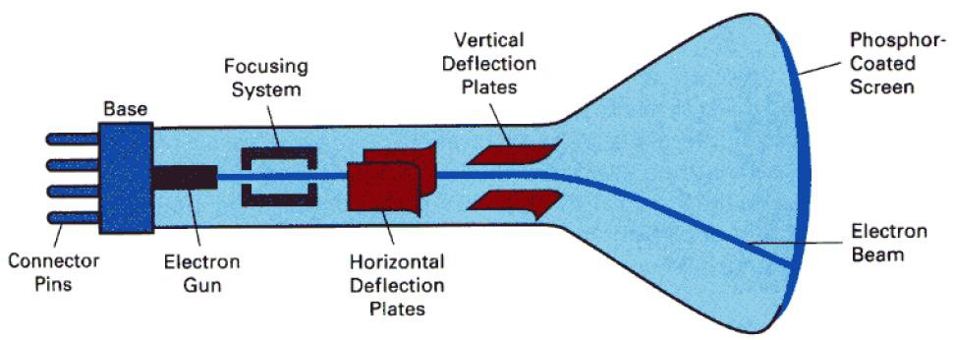

When a current flows through this heating element (filament) the conductivity of metal is reduced due to high temperature. These cause electrons to pile up on the filament. These electrons are attracted to a strong positive charge from the outer surface of the focusing anode cylinder. Due to the weaker negative charge inside the cylinder, the electrons head towards the anode forced into a beam and accelerated by the inner cylinder walls in just the way that water is speeds up when its flow through a small diameter pipe.

The forwarding fast electron beam is called Cathode Ray. A cathode ray tube is shown in figure   
below.

There are two sets of weakly charged deflection plates with oppositely charged, one positive and another negative. The first set displaces the beam up and down and the second displaces the beam left and right. The electrons are sent flying out of the neck of bottle (tube) until the smash into the phosphor coating on the other end. When electrons strike on phosphor coating, the phosphor then emits a small spot of light at each position contacted by electron beam. The glowing positions are used to represent the picture in the screen.

The amount of light emitted by the phosphor coating depends on the no of electrons striking the   
screen. The brightness of the display is controlled by varying the voltage on the control grid.

Random Scan Display System

Random Scan (vector display system or Stoke writing or Calligraphic systems):

Random scan system uses an electron beam which operates like a pencil to create a line image on   
the CRT. The image is constructed out of a sequence of straight line segments. Each line   
segment is drawn on the screen by directing the beam to move from one point on screen to the   
next, where each point is defined by its x and y coordinates. After drawing the picture, the   
system cycles back to the first line and design all the lines of the picture 30 to 60 time each   
second. When operated as a random-scan display unit, a CRT has the electron beam directed

Unit 1

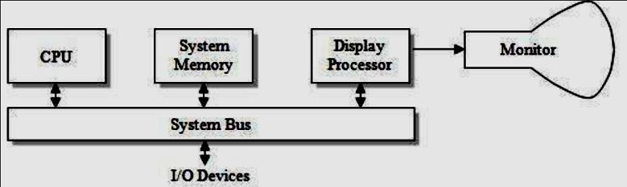

only to the parts of the screen where a picture is to be drawn. Random-scan monitors draw a picture one line at a time and for this reason are also referred to as vector displays (or stroke-writing or calligraphic displays).

Fig: Architecture of a simple random scan system

An application program is input and stored in the system memory along with the graphic   
package. Graphics commands in the application program are translated by the graphic package in   
to a display file stored in the system memory. This display file is then accessed by the display   
processor to refresh the screen. Sometimes the display processor in a random scan is referred to   
as a display processing unit or a graphics controller. Graphics patterns are drawn on a random-  
scan system by directing the electron beam along the component lines of the picture. The buffer   
stores the computer produce display list or display program which contains points and line   
plotting commands with (x,y) and end point co-ordinates as well as character plotting   
commands. The commands for plotting points lines and characters are interpreted by the display   
processor. Lines are defined by the values for their coordinate endpoints, and these input   
coordinate values are converted to x and y deflection voltages. A scene is then drawn one line at   
a time by positioning the beam to fill in the line between specified endpoints. It sends digital and   
points co-ordinates to a vector generator that converts digital co-ordinates values to analog   
voltages for beam deflection circuits that display an electron beam writing on CRT phosphor   
coating.

Unit 1

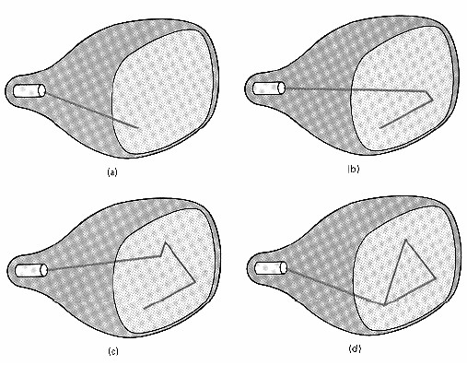

The main principal of the vector system is that the beam is deflected form end point to end point   
as detected by arbitrary order of the display commands term as random scan. Since the light   
output of phosphor decays in tens or hundreds of microseconds, the display processor must cycle   
through the display list to refresh the phosphor at least 30 times per seconds (Hz) to have flicker   
hence the buffer holding display list is usually called a refresh buffer. A CRT beam in this   
system is adjusted in such a way that electron beam only hits the spot where the graphics is to be   
drawn. Thus the refresh rate in this system depends upon the number of lines to be displayed.   
Random scan displays are designed to draw all the component lines of pictures 30 to 60 times   
per seconds. A pen plotter operates in a similar way and is an example of a random-scan, hard-  
copy device.

Advantage

It produces smooth line drawing because the CRT beam directly follows the line path definitions that are stored in the form of line drawing commands .Vector display system are mostly used for line drawing applications

Disadvantages:

When the number of command in the buffer goes high the system take long time to process and draw pictures. It cannot apply shading features and cannot display realistic shaded scenes.

Raster Graphics

In a raster-scan system, the electron beam is swept across the screen, one row at a time from top   
to bottom. As the electron beam moves across each row, the beam intensity is turned on and off   
to create a pattern of illuminated spots. Picture definition is stored in a memory area called the   
refresh buffer or frame buffer. This memory area holds the set of intensity values for all the

Unit 1

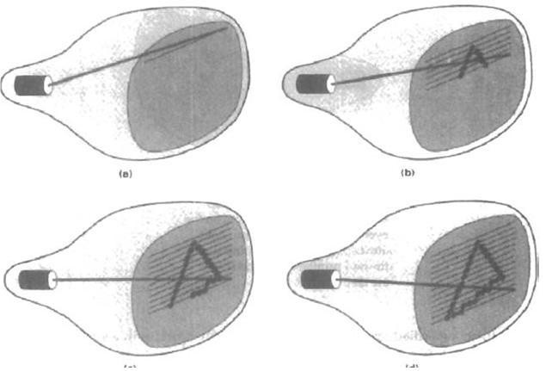

screen points. Stored intensity values are then retrieved from the refresh buffer and "painted" on   
the screen one row (scan line) at a time. Each screen point is referred to as a pixel. The capability   
of a raster-scan system to store intensity information for each screen point makes it well suited   
for the realistic display of scenes containing subtle shading and color patterns. Home television   
sets and printers are examples of other systems using raster scan methods. In raster scan each   
frame is displayed in two passes using an interlaced refresh procedure. In the first pass, the beam   
sweeps across every other scan line from top to bottom. Then after the vertical re- trace, the   
beam sweeps out the remaining scan lines. Interlacing of the scan lines in this way allows us to   
see the entire screen displayed in one-half the time it would have taken to sweep across all the   
lines at once from top to bottom. Interlacing is primarily used with slower refreshing rates. On an   
older, 30 frame- per-seconds, no interlaced display, for instance, some flicker is noticeable. But   
with interlacing, each of the two passes can be accomplished in l/60th of a second, which brings   
the refresh rate nearer to 60 frames per second. This is an effective technique for avoiding   
flicker, providing that adjacent scan lines contain similar display information. On a black and   
white system with one bit per pixel, the frame buffer is commonly called a bitmap. For systems   
with multiple bits per pixel, the frame buffer is often referred to as a pixmap. The return to the   
left of the screen, after refreshing each scan line is called the horizontal retrace of the electron   
beam. And at the end of each frame, the electron beam returns (vertical retrace) to the top left   
corner of the screen to begin the next frame.

Unit 1

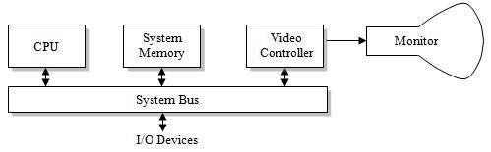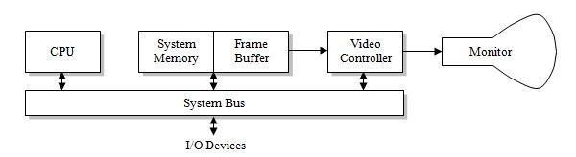

Interactive raster-graphics systems typically employ several processing units. In addition to the   
CPU, a special purpose processor called the video controller or display controller is used to   
control the operation of the display device. The figure shows the organization of a raster system.

Architecture of a simple raster system

Organization of a simple raster system is shown in Fig. above. Here, the frame buffer can be anywhere in the system memory, and the video controller accesses the frame buffer to refresh the screen. In addition to the video controller, more sophisticated raster systems employ other processors as coprocessors and accelerators to implement various graphics operations.

Video Controller

Architecture of a raster system with a fixed portion of the system memory reserved for the frame   
buffer

In some raster scan system a fixed area of the system memory is reserved for the frame buffer,   
and the video controller is given direct access to the frame buffer memory. Frame-buffer   
locations, and the corresponding screen positions, are referenced in Cartesian coordinates. For   
many graphics monitors, the coordinate origin is defined at the lower left screen corner. The   
screen surface is then represented as the first quadrant of a two-dimensional system, with   
positive x values increasing to the right and positive y values increasing from bottom to top. (On   
some personal computers, the coordinate origin is referenced at the upper left comer of the   
screen so the y values are inverted.) Scan lines are then labeled from Ymax, at the top of the   
screen to 0 at the bottom. Along each scan line, screen pixel positions are labeled from 0 to Xmax.

Unit 1

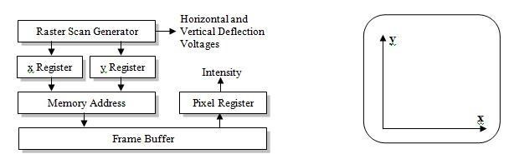

Basic refresh operations of the video controller

The basic refresh operations of the video controller are diagrammed above. Two registers are   
used to store the coordinates of the screen pixels. Initially, the x register is set to 0 and the y   
register is set to Ymax. The value stored in the frame buffer for this pixel position is then   
retrieved and used to set the intensity of the CRT beam. Then the x register is incremented by 1,   
and the process repeated for the next pixel on the top scan line. This procedure is repeated for   
each pixel along the scan line. After the last pixel on the top scan line has been processed, the x   
register is reset to 0 and the y register is decremented by 1. Pixels along this scan line are then   
processed in turn, and the procedure is repeated for each successive scan line. After cycling   
through all pixels along the bottom scan line (y = 0), the video controller resets the registers to   
the first pixel position on the top scan line and the refresh process starts over.

Screen must be refreshing at least at the rate of 60 frames per second. To speed of the pixel processing video controller can retrieve multiple pixel values from the refresh buffer on each pass. The multiple pixel intensity are then stored in a separate register and used to control the CRT bit intensity for a group of adjacent pixel. When that group of pixel has been processes the next block of pixel values is retrieved from the frame buffer. Besides these refresh operation video controller also performs different operation video controller retrieved pixel intensity from different memory area on different refresh cycle.

In high quality system, for example, two frame buffers are often provided so that gun buffer can be used for refreshing while the other is being filled with intensity values. This provides a fast mechanism for generating real time animations scenes different views of moving object can be successively loaded in the refresh buffer.

Raster-Scan Display Processor

The purpose of the display processor or graphics controller is to free the CPU from the graphics   
chores. In addition to the system memory a separate display processor memory area can also   
provided. A major task of the display processor is digitizing a picture definition given in an   
application program into a set of pixel-intensity values for storage in the frame buffer. This   
digitization process is called scan conversion. Lines and other geometric objects are converted

Unit 1

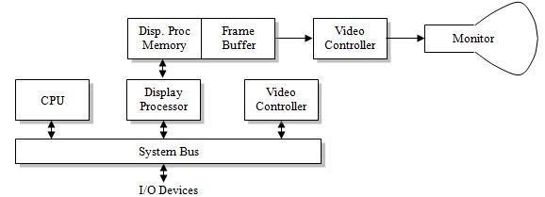

into set of discrete intensity points. Scan converting a straight-line segment, for example, means that we have to locate the pixel positions closest to the line path and store the intensity for each position in the frame buffer. Characters can be defined with rectangular grids, or they can be defined with curved outlines. Also, display processors are typically designed to interface with interactive input devices, such as a mouse.

To reduce the memory space required to store the image information, each scan line are stored   
as a set of integer pairs. One number of each pair indicates an intensity value, and the second   
number specifies number of adjacent pixels the scan line that is also having same intensity. This   
technique is called run-length encoding. Another approach is to encode the raster as a set of   
rectangular areas (cell encoding). The disadvantages of encoding runs are that intensity changes   
are difficult to make and storage requirements actually increase as the length of the runs   
decreases.

Architecture of a raster-graphics system with a display processor

Graphics Software

In computer graphics, graphics software or image editing software is a program or collection of programs that enable a person to manipulate visual images on a computer. Computer graphics can be classified into two distinct categories: raster graphics and vector graphics. Many graphics programs focus exclusively on either vector or raster graphics, but there are a few that combine them in interesting ways. It is simple to convert from vector graphics to raster graphics, but   
going the other way is harder. Some software attempts to do this. In addition to static graphics, there are animation and video editing software. Most graphics programs have the ability to   
import and export one or more graphics file formats.

Software standards

The Primary goal of standardized graphics software is portability. Without standards, programs designed for one hardware system often cannot be transferred to another system without   
extensive rewriting of the programs. Graphical Kernel System(GKS) was adopted as the the first graphics software standard by ISO and by various national standard organizations ANSI.   
Programmer’s Hierarchical Interactive Graphics Standard PHIGS which is the extension of GKS was developed later on. Standardization for device interface methods is given in the Computer Graphics Interface (CGI) system. And the Computer Graphics Metafile (CGM) system specifies standards for archiving and transporting pictures.

Now Open GL is used in most of graphic software. OpenGL is a software interface to graphics   
hardware. This interface consists of about 150 distinct commands that you use to specify the   
objects and operations needed to produce interactive three-dimensional applications. OpenGL is   
designed as a streamlined, hardware-independent interface to be implemented on many different   
hardware platforms. To achieve these qualities, no commands for performing windowing tasks or   
obtaining user input are included in OpenGL; instead, you must work through whatever   
windowing system controls the particular hardware you’re using. Similarly, OpenGL doesn’t   
provide high-level commands for describing models of three-dimensional objects. Such   
commands might allow you to specify relatively complicated shapes such as automobiles, parts   
of the body, airplanes, or molecules.

With OpenGL, you must build up your desired model from a small set of geometric primitives -  
points, lines, and polygons. A sophisticated library that provides these features could certainly be built on top of OpenGL. The OpenGL Utility Library (GLU) provides many of the modeling   
features, such as quadric surfaces and NURBS curves and surfaces. GLU is a standard part of   
every OpenGL implementation.

Scan Conversion Algorithms (Line, Circle, Ellipse)

Digital devices display a straight line segment by plotting discrete points between the two endpoints. Discrete coordinate positions along the line path are calculated from the equation of the line. For a raster video display, the line color (intensity) is then loaded into the frame buffer at the corresponding pixel coordinates. Reading from the frame buffer, the video controller then "plots" the screen pixels. Screen locations are referenced with integer values, so plotted positions may only approximate actual Line positions between two specified endpoints.

For the time being, we will assume that pixel positions are referenced according to scan-line number and column number (pixel position across a scan line). Scan lines are numbered consecutively from 0, starting at the bottom of the screen; and pixel columns are numbered from 0, left to right across each scan line.

Line drawing Algorithm

Unit 1

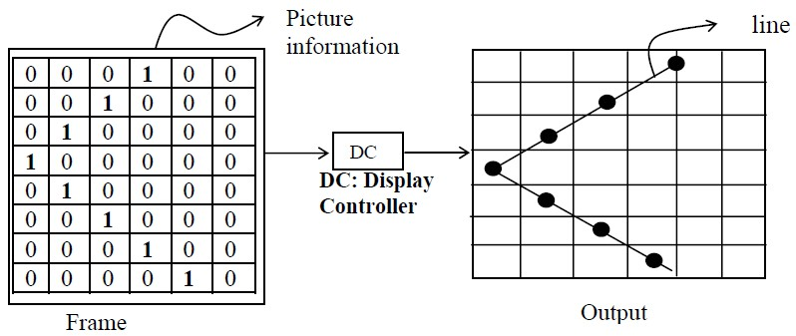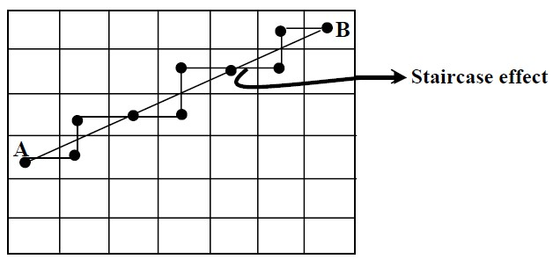

In case of frame buffer , the information about the image to be projected on the screen is stored in an m*n matrix, in the form of 0s and 1s; the 1s stored in an m* n matrix positions are brightened on the screen and 0’s are not brightened on the screen and this section which may or may not be brightened is known as the Pixel (picture element). This information of 0s and 1s gives the required pattern on the output screen i.e., for display of information. In such a buffer, the screen is also in the form of m* n matrix, where each section or niche is a pixel (i.e., we have m* n pixels to constitute the output).

Sometime the line may have a slope and intercept and its information is required to be stored in   
more than one section of the frame buffer, so in order to draw or to approximate such the line,   
two or more pixels are to be made ON. Thus, the outcome of the line information in the frame   
buffer is displayed as a stair; this effect of having two or more pixels ON to approximating a line   
between two points say A and B is known as the Staircase effect. The concept is shown below in   
figure .

DDA

Line drawing is accomplished by calculating intermediate point coordinates along the line path   
between two given end points. Since screen pixels are referred with integer values, or plotted

Unit 1

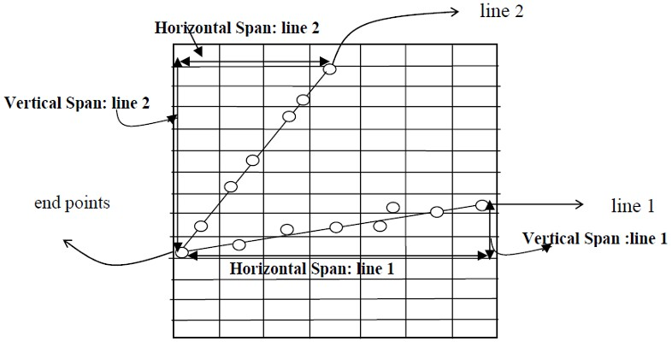

positions, which may only approximate the calculated coordinates - i.e., pixels which are

intensified are those which lie very close to the line path if not exactly on the line path which in   
this case are perfectly horizontal, vertical or 45° lines only. Standard algorithms are available to   
determine which pixels provide the best approximation to the desired line, one such algorithm is   
the DDA (Digital Differential Analyser) algorithm. Before going to the details of the algorithm,   
let us discuss some general appearances of the line segment, because the respective appearance   
decides which pixels are to be intensified. It is also obvious that only those pixels that lie very   
close to the line path are to be intensified because they are the ones which best approximate the   
line. Apart from the exact situation of the line path, which in this case are perfectly horizontal,   
vertical or 45° lines (i.e., slope zero, infinite, one) only. We may also face a situation where the   
slope of the line is > 1 or < 1.Which is the case shown in Figure below

In Figure above , there are two lines. Line 1 (slope<1) and line 2 (slope>1). Now let us discuss the general mechanism of construction of these two lines with the DDA algorithm. As the slope of the line is a crucial factor in its construction, let us consider the algorithm in two cases   
depending on the slope of the line whether it is > 1 or < 1.

Case 1: slope (m) of line is < 1 (i.e., line 1): In this case to plot the line we have to move the direction of pixel in x by 1 unit every time and then hunt for the pixel value of the y direction which best suits the line and lighten that pixel in order to plot the line.

So, in Case 1 i.e., 0 < m < 1 where x is to be increased then by 1 unit every time and proper y is approximated.

Case 2: slope (m) of line is > 1 (i.e., line 2) if m > 1 i.e., case of line 2, then the most   
appropriate strategy would be to move towards the y direction by 1 unit every time and   
determine the pixel in x direction which best suits the line and get that pixel lightened to plot the   
line. So, in Case 2, i.e., (infinity) > m > 1 where y is to be increased by 1 unit every time and   
proper x is approximated.

Unit 1

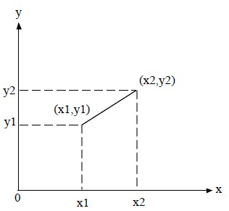

We have assumed that the line generation through DDA is discussed only for the first quadrant, if the line lies in any other quadrant then we apply respective transformation.

Complete algorithm

The Cartesian slope equation of a straight line is, y = mx+b ………………….(i) When m represents the slope of the line and b as the y -intercept.

Suppose two end points of a lien segment at positions (x1, y1) and (x2, y2) are shown in figure.   
m = (y2 - y1)/ (x2 -x1) …………………………………………………………………. (ii)

b = y - mx …………….(iii)

For any given x-interval △x along the line, we compute the corresponding y- intercept △y form equation (ii).

△ y = m △x …………………(iv)

△x =m/Δ y

These equations form the basis of determining deflection voltage in analog devices.

Case: I

For

|m| < 1,

Then △x can be proportional to a small horizontal deflection voltage and the corresponding vertical deflection is set to △y as calculated from equation (iv).

Case: II

For |m| >1

Then, △y can be set proportional to a small vertical deflection voltage with the corresponding horizontal voltage set proportional to △x calculated from equation (V)

Case III

When m = 1, then △x = △y and then horizontal and vertical voltages equal.

Comments:

1. It uses multiplication

2. It uses float operation.

DDA ( Digital differential Analyzer):

This algorithm samples the line at unit interval in one-coordinate and determines corresponding integer values nearest the line path for other co-ordinates. The equation of the line is,   
Y = mx+b………………….(i)

m = (y2-y1)/(x2-x1) ………………..(ii)

For any interval △ x , corresponding interval is given by △y = m △x.

Case I :

|m| < 1 , we sample at unit x interval i.e △ x = 1. xk+1 = xk  +1 ……………..(iii)

Then we compute each successive y-values, △ y = m yk+1 = yk + m ……………………..(iv)

Case: II

|m| > 1, we sample at unit y-interval i.e △y = 1 and compute each successive x-values. Therefore, 1 = m △x

△x = 1/m

xk+1- xk = 1/m……………..(v)   
yk+1 = yk + 1…………….(vi)

Above equation hold for the lines processed from left end to right end. For the reverse process i. e if the line is to be processed form right to left then,

Case: III

For|m| <1, △x = -1

xk+1 = xk-1 ……………………………….. (vii)   
yk+1 = yk- m ……………………………….(viii)

Case: IV

For |m| >1, △y = -1

yk+1 =yk -1 ……………………(ix) Xk+1= xk -1/m…………….(x)   
Therefore , in general,

yk+1 = yk ± m

xk+1 = xk ± 1 for |m| < 1 yk+1= yk ± 1

xk+1 = xk ± 1/m for |m| >1

Algorithm:

1. Declare the variables, x1,y1 and x2 , y2 ,dx, dy ,del x, del y as real and k as integer.

2. Perform

Unit 1

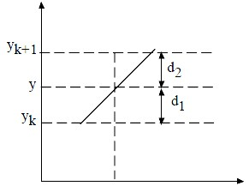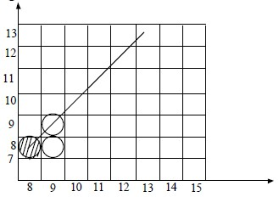

dx = x2-x1   
dy = y2 - y1

3. Test if |dy|<|dx| then Steps = |dx| Else steps = |dy|

4. set del x = dx/steps

del y = dy/steps

x= x1

y = y1

5. Plot (x, y)

6. Do for k = 1 to steps x = x+ delx

y = y +del y   
Plot (x,y)   
End do.

Bresenhan’s line Algorithm (BLA):

DDA includes calculation related to m and 1/m which is little complicated since it produce float values. Bresenhan’s improves DDA algorithm by only involving integer calculation. Bresenham algorithm is accurate and efficient raster line generation algorithm. This algorithm scan converts lines using only incremental integer calculations and these calculations can also be adopted to display circles and other curves.

Case I:

|m| < 1 m >0

Let (xk, yk) be the pixel position determined then the next pixel to be plotted is either (xk+1,yk) or (xk+1,yk+1)

Let d1 and d2 be the separation of pixel position (xk+1, yk) and (xk+1, yk+1) from the actual line path.

y = mx +b

Then, at sampling position (xk +1) y = m (xk+1) +b

From figure above : d1 = y - yk

d2 = yk+1- y

d1 - d2 = (y -yk) - (yk+1-y)

Let us define a decision parameter pk for the kth step by pk = △ x (d1- d2)

Since △x > 0 ,

Therefore, pk <0 if d1 < d2 pk ≥ 0 , if d1 > d2

pk = △x{ y-yk -(yk+1 - y )}

= △x{ y-yk- yk-1+y} since, yk+1 = yk+1 = △x{ 2{ m(xk+1)+b} - 2 yk - 1}

pk = △x{2mxk + 2m + 2b-2xk-1} since, xk+1= xk+1

pk = 2mxk △x - 2yk △x +(2m+2b-1) △x

pk = 2. (△y/△x).xk △x -2yk △x +( 2m+2b-1) △x

pk = 2 △y xk - 2 △x yk +c …………………………….. (i)

Where, C = (2m+2b-1) △x is a constant.

Now, for next step,

pk+1 = 2 △x xk+1 - 2 △x yk+1 +c………….(ii) From (i) and (ii)

pk+1 - pk = 2 △y (xk+1- xk) - 2 △x ( yk+1- yk)   
i.e pk+1 = pk +2 △y - 2 △x ( yk+1 -yk)   
Where,

yk+1 - yk = ‘0’ or ‘1’

If pk< 0 , then we plot lower pixel   
yk+1 = yk ………………(iii)   
pk+1 = pk +2 △y ………….(iv)

If pk ≥ 0 then we plot upper pixel.

Therefore, yk+1 = yk+1…………..(v)

pk+1 = pk + 2 △y - 2 △x …………(vi)

Unit 1

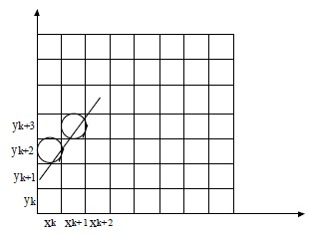

Therefore, initial decision parameter.

P0 = 2 △y xo - 2 △x yo + c [from equation (i)]   
= 2 △y xo- 2 △xyo +( 2m+ 2b-1)△x   
= 2△y xo - 2 △x yo + 2 m △x + 2b △x - △x

= 2 △y xo- 2△x yo + 2. (△y/△x).△x + 2 ( yo - mxo)△x - △x = 2 △y xo - 2 △x yo + 2 △y + 2 △xyo+ 2 △y/△x. xo △x - △x Po = 2 △y - △x

We can summarize Bresenham line drawing for a line with a positive slope less

than 1 in the following listed steps. The constants 2△y and 2△y - 2△x are calculated once for each line to be scan converted, so the arithmetic involves only integer addition and subtraction of these two constants.

Bresenham’s line algorithm: ( For |m|<1)

1. Input the tow line end points and store the end point in (x0,y0)

2. Load (x0, y0) into the frame buffer; that is plot the first point.

3. Calculate constants △x, △y , 2 △y and 2 △y - 2 △x and obtain the starting value for the decision parameter as ;

po = 2 △y - △x

4. At each xk along the line, starting at k= 0 , perform the following test:   
If pk <0 the next point to plot is ( xk+1, yk) and pk+1 = pk +2 △y.   
otherwise, the next point to plot is ( xk+1, yk+1) and pk+1= pk+ 2△y - 2 △x

5. Repeat step 4 △x times.

For |m|>1

Case II:

Let (xk, yk) be the pixel position determined then the next pixel to the plotted is

either ( xk+1, yk+1) or ( xk, yk+1)

Let d1 and d2 be the separation of the pixel positons ( xk, yk+1) and ( xk+1, yk+1) for the actual line path.

y = mx +b

The actual value of x is given by x = (y-b)/m

Now, sampling position at yk+1 Form figure,

d1 = x - xk   
d2 = xk+1 - x

Let us define a decision parameter pk

pk = △y ( d1- d2)

As before , it is calculated as : pk = 2 △x yk - 2△y xk + c

Similarly we derive the expression for pk  and pk+1

If pk ≥ 0

pk+1 = pk + 2 △x - 2 △y

We plot , xk+1 = xk+1, yk+1 = yk+1   
pk < 0

pk+1 = pk+ 2 △x

For initial parameter, we derive Po = 2 △x - △y

So we conclude ,

m < 1, we take x-direction sample. xk+1 = xk+1   
m > 1, we take y-direction sample. yk+1 = yk +1   
For developing algorithm , we assume following :

* Bresenhams algorithm is generalized to lines with arbitrary slopes by considering the   
   symmetry between the various octants and quadrants of the coordinate system.
* For line with +ve slope (m) such that m > 1, then we interchange the roles of x and y

direction i.e., we step along y directions in unit steps and calculate successive x values nearest the line path.

* For -ve slopes the procedures are similar except that now, one coordinates decreases as   
   the other increases.

Bresenham’s Complete algorithm:

1. Input the two end points (x1,y1) and (x2,y2)

2. Compute dx= |x2 -x1| and dy = |y2 -y1|

3. If x2 - x1 < 0 and y2 -y1 > 0 or x2-x1>0 and y2 - y1 < 0. Then set a = -1, else a = 1

4. If dy < dx then,

i. If x1>x2 then, t = x1 ; x1 = x2 ; x2= t   
 t = y1 ; y1 = y2 ; y2 = t

ii. Find initial decision parameter P = 2dy - dx iii. Plot the first pixel (x1, y1)

iv. Repeat the following till |x1| < |x2|

a. If P< 0 then,

P = P+ 2dy

Else, P = P+ 2dy - 2dx   
y = y1+a

b. Increase x1 by 1 i.e x1 = x1+1

c. Plot (x1,y1)

5. Else |m|>1

i. Check if (y1>y2) then,

t = x1; x1 = x2 ; x2 = t

t = y1 , y1 = y2 ; y2 = t.

ii. Find initial decision parameters. P = 2dx - dy iii. Plot the first point (x1,y1)

iv. Repeat the following till y1 < y2

a. If P< 0 then , P = P+2dx.   
 Else, P = P+ 2dx-2dy

x1 = x1 +a

b. Increase y1 by 1. i.e y1 = y1+1

c. Plot (x1,y1)

Circle drawing algorithm

Circle: A cicle is defined as a set of points that are all at a given distance ‘r’ from the centre

position (xc, yc). This distance relationship is expressed by the Pythagorean theorem in Cartesian co-ordinate as (x - x1)2 + (y-y1) 2 = r2

Methods to draw circle:

a. Direct method

b. Trigonometric method

c. Midpoint Circle method.

Direct method:

x2 +y2 = r2 ; y =

Trigonometric method:

x = xcosθ , y = ysinθ

Bresenham’s mid point algorithm :

This is also a scan conveting algorithm . The equation of the circle with the centre (h,k) is given by , (x-h)2 +(y-k)2 = r2 ……….(i)

When, h = 0, x = 0 then the equation of the circle at origin x2+y2 = r2 ……………(ii)

Unit 1

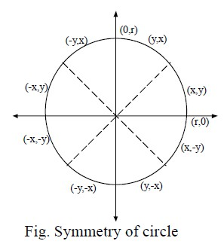

Differentiating both sides, 2x+2y dy/dx = 0

Or dy/dx = -x/y , where , dy/dx = slope Now , if dy/dx = 0, then x = 0.   
If, dy/dx = -1, then x = y

Consider circle section for x = 0, x = y where slope of the curve varies from 0 to1.Calculation of circle point (x,y) in one octant gives the circle point shown for the other seven octants. To apply the mid point we define a circle function as,

fcircle (x,y) = x2+y2 - r2 …………..(iii)   
Suppose,

f(x,y) = < 0 if (x,y ) is inside the circle boundary.   
 = 0 if (x,y) is on the circle boundary.

>0 , if (x,y ) is outside the circle boundary.

The circle function tests are performed for the mid position between pixels near the circle path at each sampling step.

Unit 1

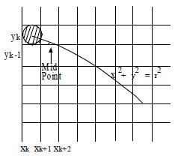

Figure: Midpoint between candidate pixels at sampling position xk+1 along a circular path.

Assume that we have just plotted the pixel (xk, yk). We next need to determine whether the pixel at position (xk +1,yk) or the one at the position (xk +1,yk-1) is closer to the circle. The decision parameter pk is the circle function which we have evaluated in equation (iii) at the midpoint   
between these two pixels.

i,e pk = fcircle ( xk+1, yk-1/2)

= (xk +1)2 +(yk -1/2)2 - r2 …………..(iv)

If pk< 0 , this mid pixel is inside the circle and the pixel on the scan line yk is closer to the circle   
boundary . Otherwise the midpoint is outside or on the circle boundary , and we select the pixel   
yk -1, successive decision parameters can be obtained similarly using incremental calculations.

We obtained a recursive expression for the next decision parameter by evaluating the circle function at sampling position.

xk+1 +1 = xk +2

pk+1 = fcircle (xk+1+1 ,yk+1 - 1/2)

= (xk+1+1)2 + ( yk+1-1/2)2 - r2 ………………(v) Subtracting equation (iv) from (v).

pk+1 - pk = [ (xk+1) + 1 )]2 + (yk+1- 1/2)2 - (xk +1)2- (yk-1/2 )2 ….(vi) pk+1 = pk + 2(xk + 1)+( y2k+1 - y2k) - (yk+1 - yk) + 1

where yk+1 is either yk or yk-1,, depending on the sign of pk.Increments for obtaining pk+1 are either 2xk + 1 (if pk is negative) or 2xk+ 1 - 2yk+l. Evaluation of the terms 2k+1and 2yk+1 can also be done incrementally as

2xk+1 = 2xk+2   
2yk+1= 2yk-2

At the start position (0, r), these two terms have the values 0 and 2r, respectively. Each

successive value is obtained by adding 2 to the previous value of 2x and subtracting 2 from the previous value of 2y.

The initial decision parameter is obtained by evaluating the circle function at the start position (x0, y0) = (0, r):

Hence, p0 = fcircle(x0+1, y0- 1/2) = fcircle( 1, r-1/2)

= 1+ (r-1/2)2 -r2

= 1 + r2 - r + 1/4 - r2 p0 = 5/4 - r

since 5 and 4 are integer values so if the radius r is specified as an integer, we can simply round p0 to p0 = 1-r (for r an integer) since all increments are integers.

p = 1-r ……….(vii)

Unit 1

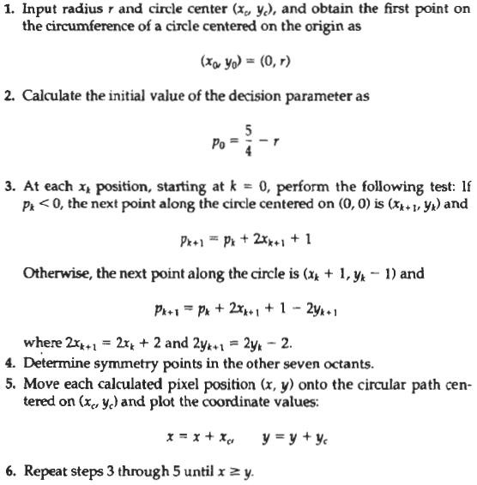

Unit 1

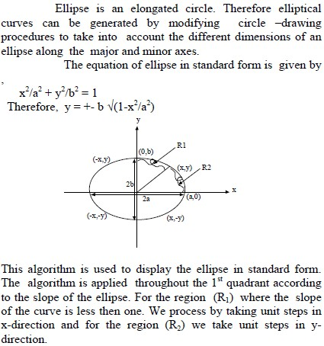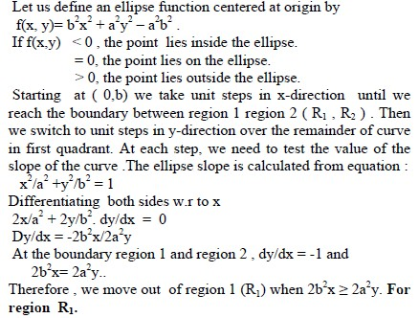

Ellipse Algorithm

Unit 1

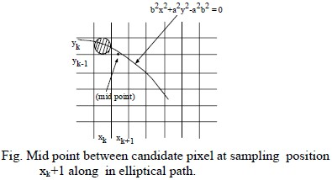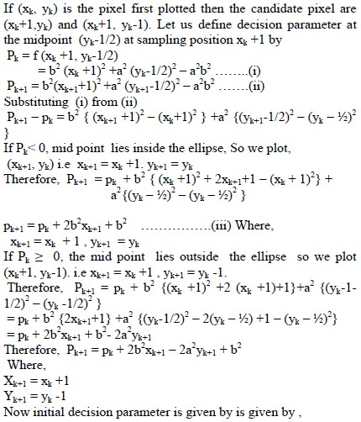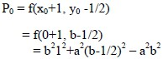

Unit 1

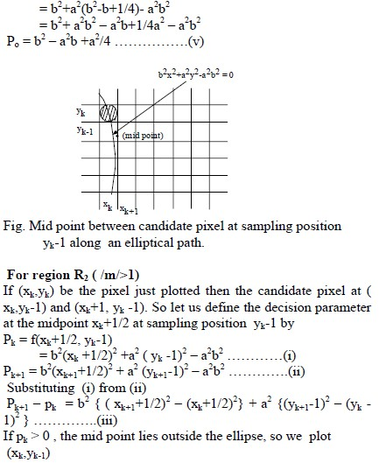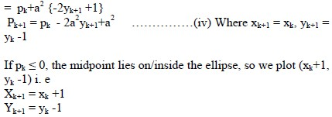

Unit 1

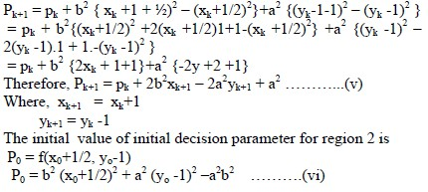

(x0,y0) for region 2 is the last point for region 1. The pixel for other quadrant are determined by   
symmetry

Complete Algorithm:

1. Obtain the centre xc,yc semi-major and semi-minor axis length as a and b.

2. Set x = 0, y = b

3. Plot the point (x,y) and its symmetry points at appropriate positions by x = x+xc , y = y+yc

4. Compute initial decision parameter for R1 , P1 = b2-a2b2+a2/4

5. Repeat the following till 2b2x < 2a2y

i. x = x+1

ii. Test if P1 < 0 then   
P1 = P1 +2b2x+b2Else,

y = y-1

P1 = P1+2b2x- 2a2y = b2

iii. Plot the points (x,y) and its symmetry points at approximate position by x = x+xc y = y+yc

6. Compute initial decision parameter for R2

P2 = b2(x+0.5)2 + a2 (y-1)2 - a2b2

7. Repeat the following till y>0

i. y = y-1

ii. Test if P2 > 0 then P2 = P2 - 2a2y +a2Else,

x = x+1

P2 = P2 +2b2x - 2a2y + a2

iii. Plot the points (x,y) and its symmetry points at approximate points by x = x+xc , y = y +yc